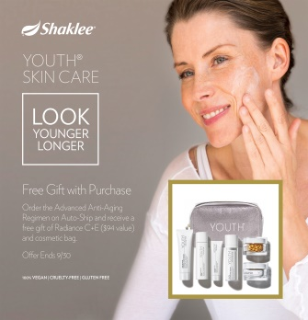
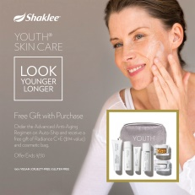

Shaklee YOUTH SKIN CARE Order Form
Name________________________________
Address______________________________
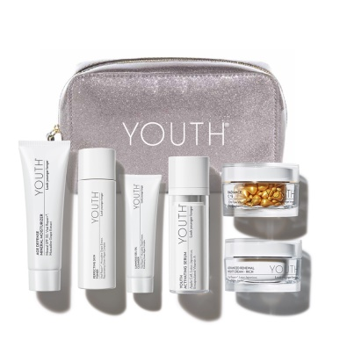
Tel#__________ Email__________________
Credit Card________________________
Exp. Date____ Card Code____________

- Advanced Anti-Aging Regimen #89453____
Price $388.10 NOW only $294.10 plus tax and shipping
Receive free cosmetic bag
- Youth Activating BB Cream $41.20
1-32575 Light ______ 2-32576 Light Med ____
3-32577 Medium_____ 4-32578 Dark _____

Shifra Lefkowitz, Anti-Aging specialist 718-387-0072
www.shifra.myshaklee.com

